**Green Fund HACK-A-THON**

**Table of contents:**

* Introduction
* Setup
* How To Use the App
* Screenshots to show the Functionality of the app

**Acknowledgements:**

We would like to express our gratitude to professor Dr. Somya Mohanty and Will Queen for providing their support in clarifying our doubts. Our special thanks to UNCG Green Fund for funding this Hackathon.

**1.Introduction :**

An interactive dashboard is developed in this project to summarize high-frequency energy consumption data in 81 electricity meters on UNCG’s campus. These meters represent power utilization of various buildings across UNCG and will help the university understand the requirements and usage of energy consumption and efficiency across the campus.

Prior work in the project has achieved scripts to clean, summarize, and predict energy use using statistical models with data on meter readings, local weather conditions, and classroom occupancy. These scripts are written in Python and extract data from various API sources. The available cleaned data is available at: <https://github.com/UNCG-DAISY/Green_Hackathon-Fall2020/tree/main/data/Analysis> .

**2. Setup:**

To get started, you will need to either be running editors like Pycharm Professional editor or Visual Studio editor.

**2.1 Installing Basic Tools and Dependencies :**

There are some basic tools you will need for the project. Git will allow you to pull the project from GitHub repository and pip is an installer for the required Python libraries make sure you have them .

There are some dependencies for the project. Run these commands in your terminal to install them.

pip install dash

pip install pandas

pip install xlrd

pip install dash-bootstrap-components

**2.2 Cloning the repository:**

With these required dependencies installed, now it is required to get the actual code for the project and put it in the environment. You can run the following command in the terminal of the editor to clone the repo.

Cd && git clone https://github.com/UNCG-CSE/Hackathon-DataCrackers.git

**3. How To Use the App:**

On the left navigation bar one can see two options as below

1. Energy Consumption & Prediction (Task-1)
2. Average Predictions By Group (Task-2)

When the user clicks **Energy Consumption & Prediction** button user can see as below

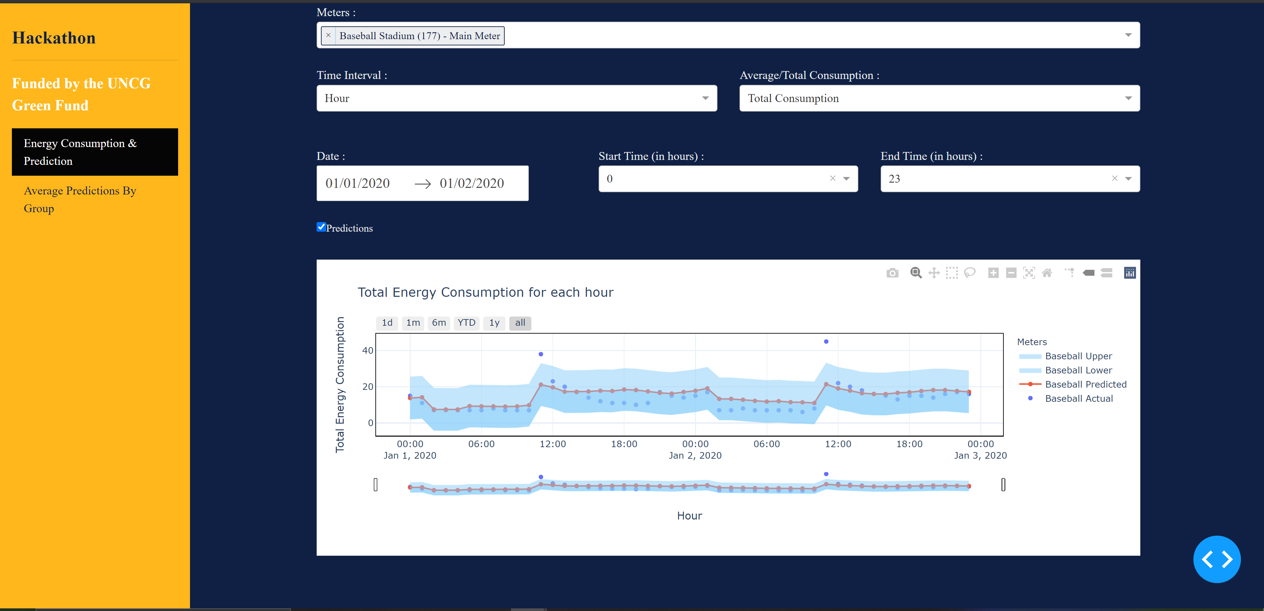

When the user clicks Average Predictions By Group button a new page opens as below

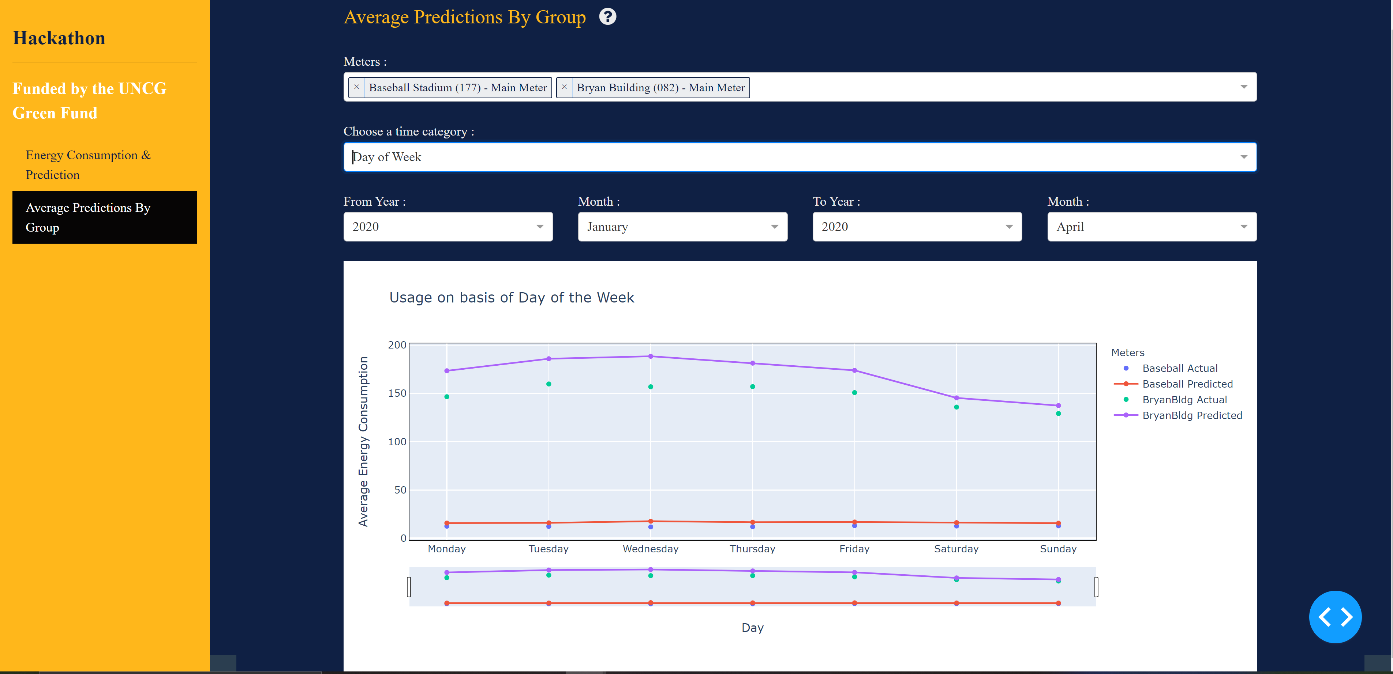

**3.1 Energy Consumption & Prediction :**

Meters:

User can select one or multiple meters at a time using the this dropdown to visualize the graph.

Time Interval :

There are 5 options for user to select under Time Interval dropdown as

1. Year
2. Month
3. Week
4. Day
5. Hour

User can select one at a time. For instance, If user wants to know week’s energy consumption he can select week in Time interval. If user wants to know about hour’s energy consumption, he can select hour in Time Interval.

**1. Hour**: Please select to and from dates and to and from hours(Note: Select dates which are less than 6 months to check the hourly consumption otherwise it may take a longer time to load).  
**2. Week:** Once user clicks on week user will get Year and week dropdown and you can select both the options and you can see the consumption graph for the weeks of the selected year.  
**3. Month:** Once user selects the dates from the date picker, user will get all the months consumption for that specific period of time.  
**4. Year:** Once user selects the dates from the date picker, user will get the years consumption for the selected period of time.  
**5. Day:** Once user selects the to and from dates from the date picker user will get the daily consumption of all the dates between the selected dates.

Average/Total Consumption:

There are 2 options for user in Average/Total Consumption button.

1. Total Consumption
2. Average Consumption

For Instance user can select Total Consumption if he wants to know about the total consumption of the meters in the particular time interval. Similarly if user selects Average Consumption the graph will be displayed for the average consumption of energy for the meters.

Date :

In Date picker user can select date from the calendar that appears after clicking it. There are both From date and To date user can select particular dates.

Start Time(in hours):

This is the dropdown where user can select particular hour as there are 24 hours in a day user has 24 options to select.

End Time (in hours):

This is the dropdown where user can select particular hour.

Predictions :

User can select Predictions check box. If he checks it he can able to see both the actual and predicted values in the graph for the conditions that he had selected.

For hourly Consumption prediction level also will be displayed on the graph.

**3.2 Average Predictions By Group:**

Meters :

In Meters dropdown there are 81 meters included so, user can select one or multiple meters at a time to visualize the graph. If user clicks x on the selected meter he can remove that meter from the selected meters.

Choose a time category:

In Choose a time Category dropdown user has four options as below

1. Hour of Day
2. Day of Week
3. Week of Year
4. Month of Year

A graph for the 2020 year average predictions data will be displayed for the particular selected category by the user.

For instance, if the user chooses hour of day, the Bryan Building meter. The graph would plot the average actual and average predicted consumption in Bryan from for the year 2020 by hour of the day. There would be one observation per hour in a day so 24 in total.

There is a range slider and selector are there for every graph where user can drag and move along the x-axis to see the detailed data.

1d --- data for 1 day

1m -- data for 1 month

6m – data for 6 months

YTD -- Year to Date data

1y -- 1 year data

All – all data

**3.3 Help (?) :**

If user clicks on the ? symbol a some instructions will be displayed to guide the process.

**4. Screenshots to show the functionality of App:**

* 1. The below screenshot shows the average energy consumption for a year for Baseball Stadium meter.

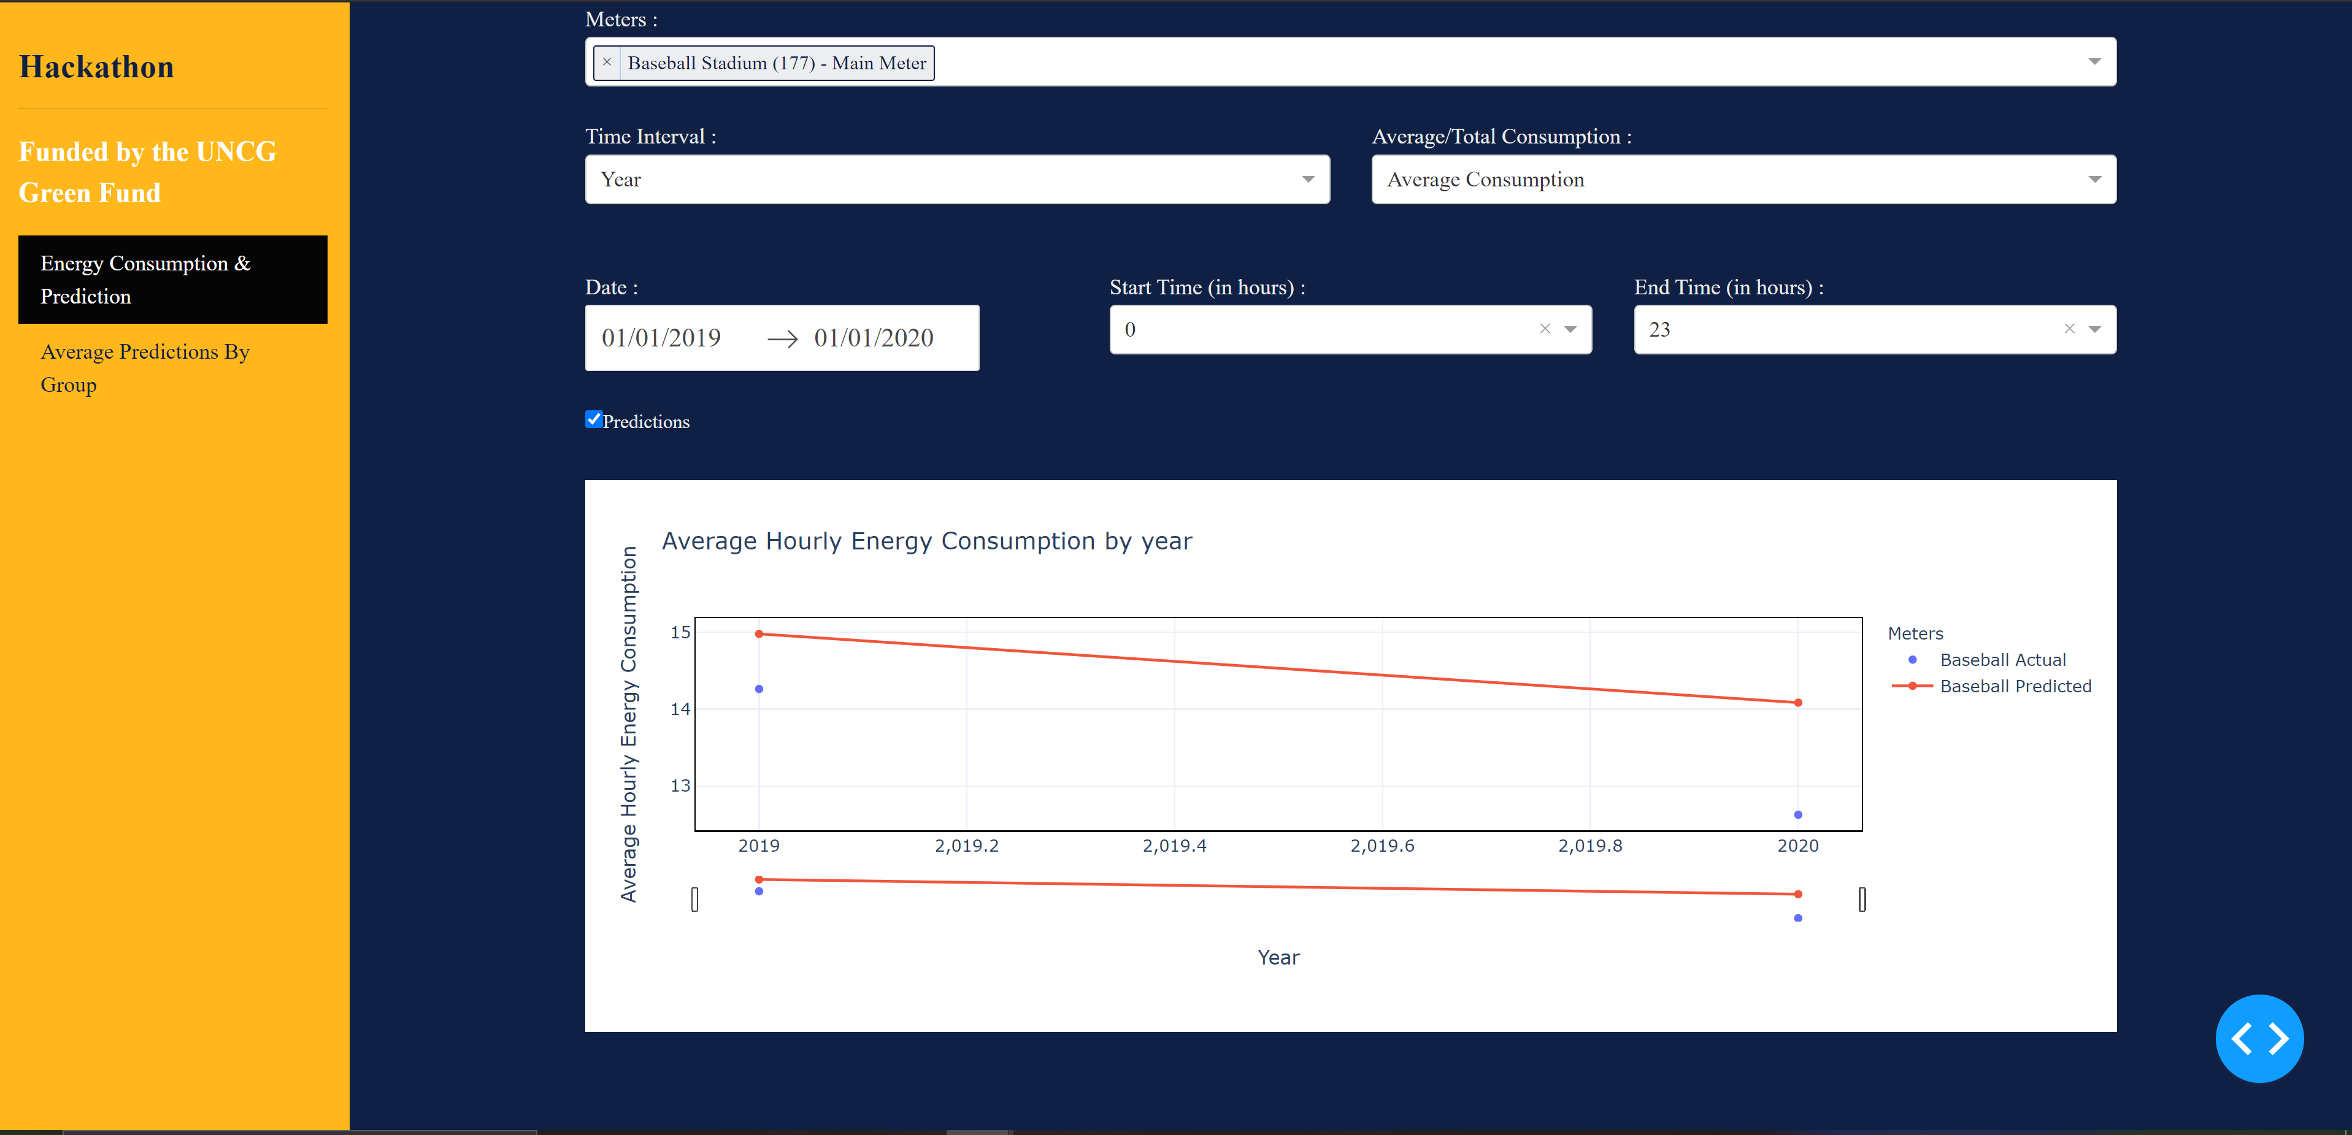

4.2 The below screenshot shows the Total energy consumption for a year for Baseball Stadium meter.

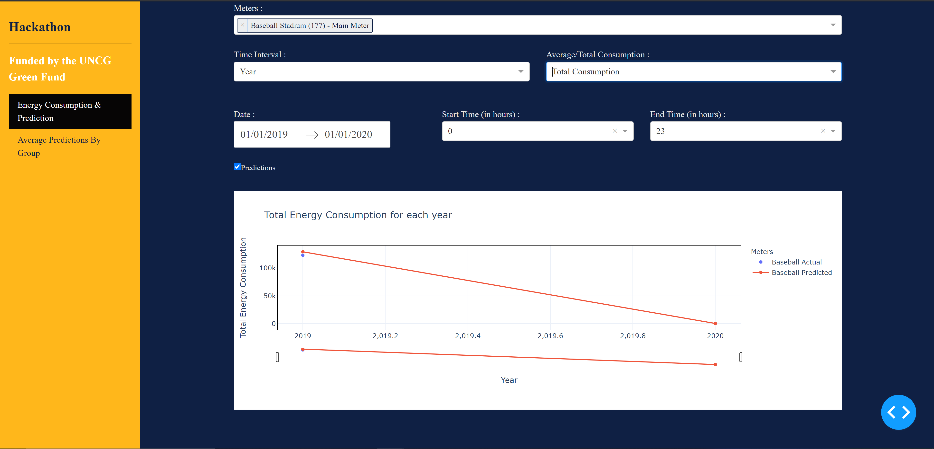

4.3The below screenshot shows the average energy consumption for each month

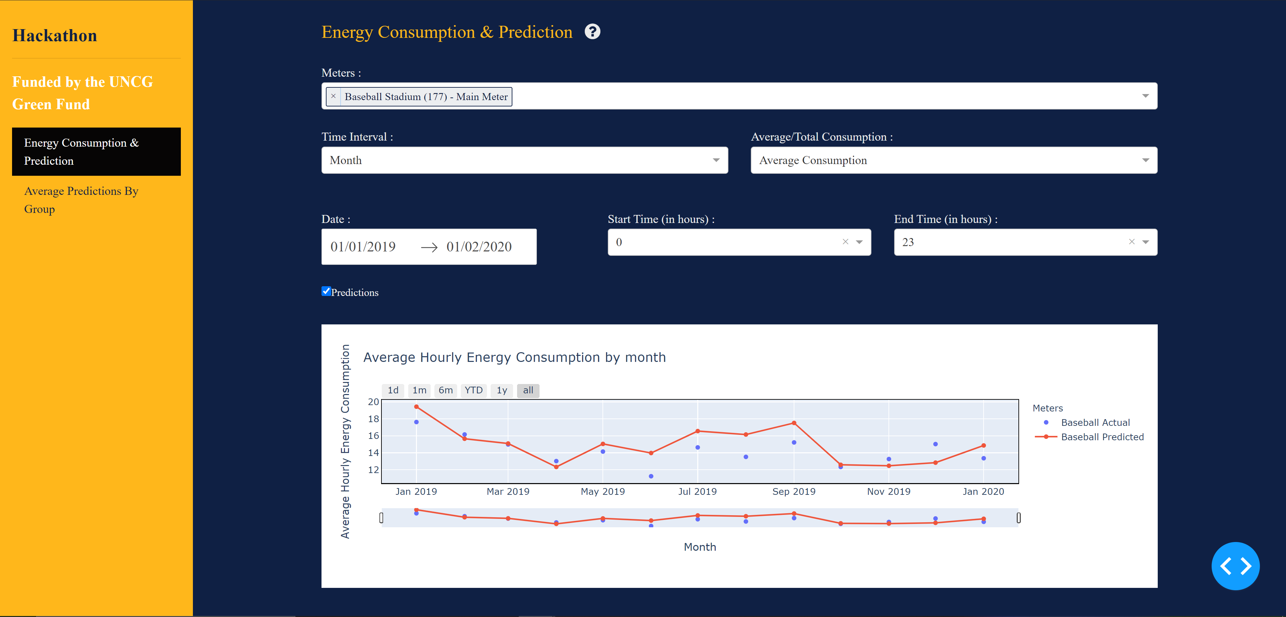

* 1. The below screenshot shows the total energy consumption for each month

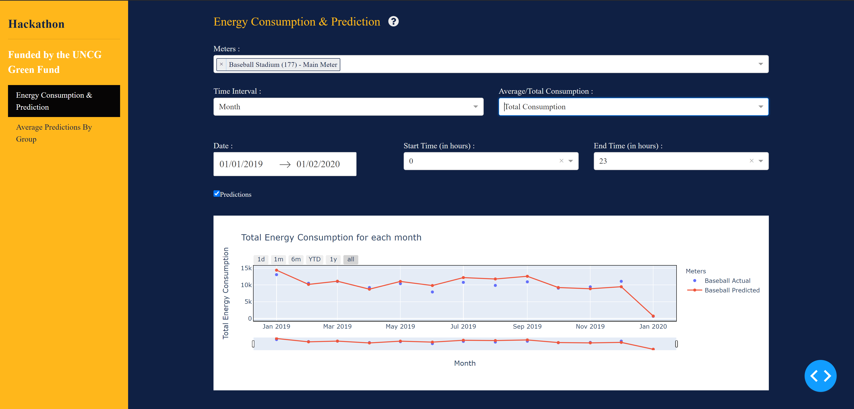

4.5 The below screenshot shows the Average hourly consumption by week for 2018 and 2019 years and for 30 and 35 weeks.

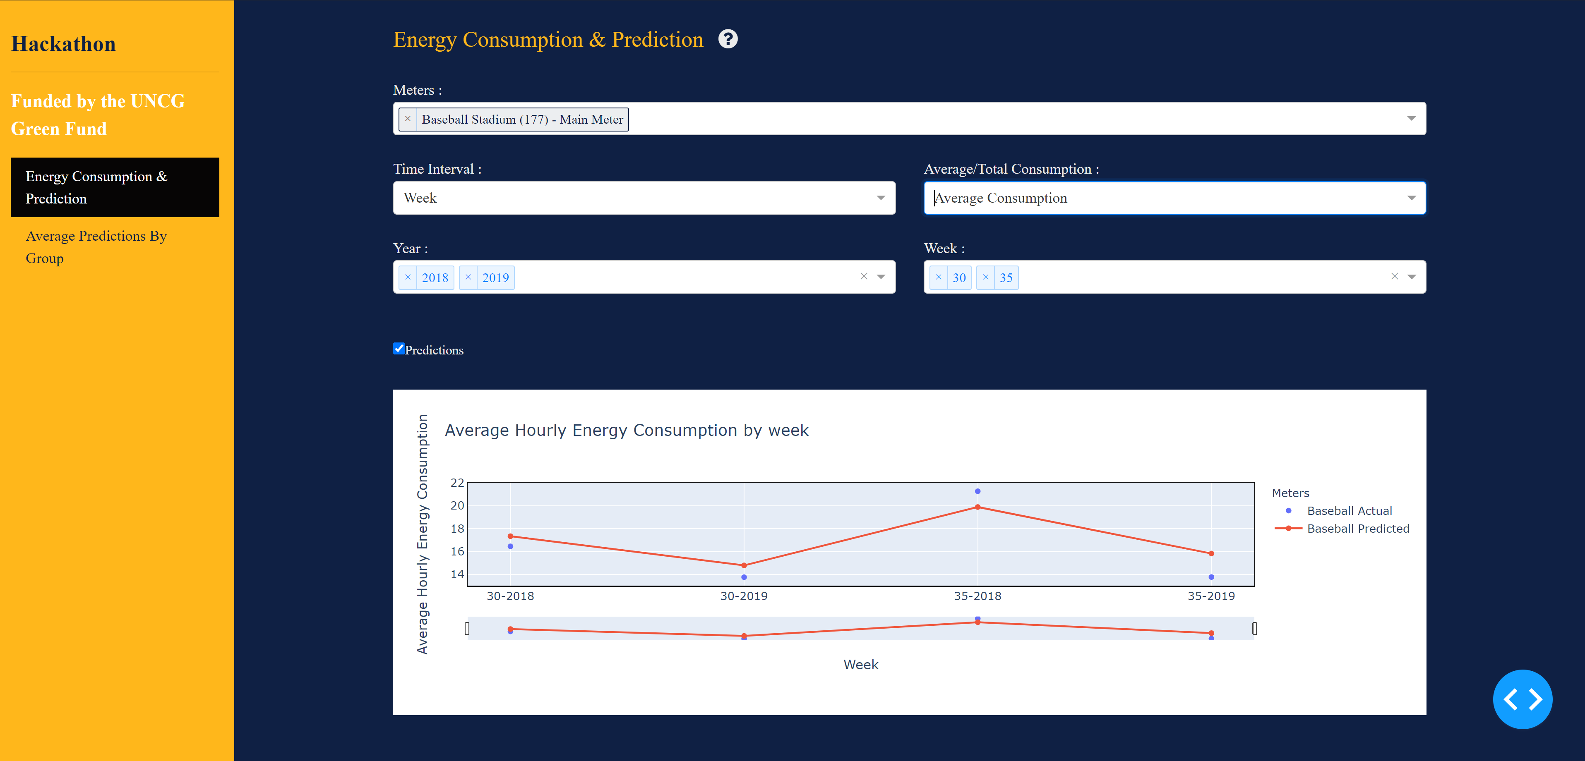

* 1. The below screenshot shows the Total hourly consumption by week for 2018 and 2019 years and for 30 and 35 weeks.

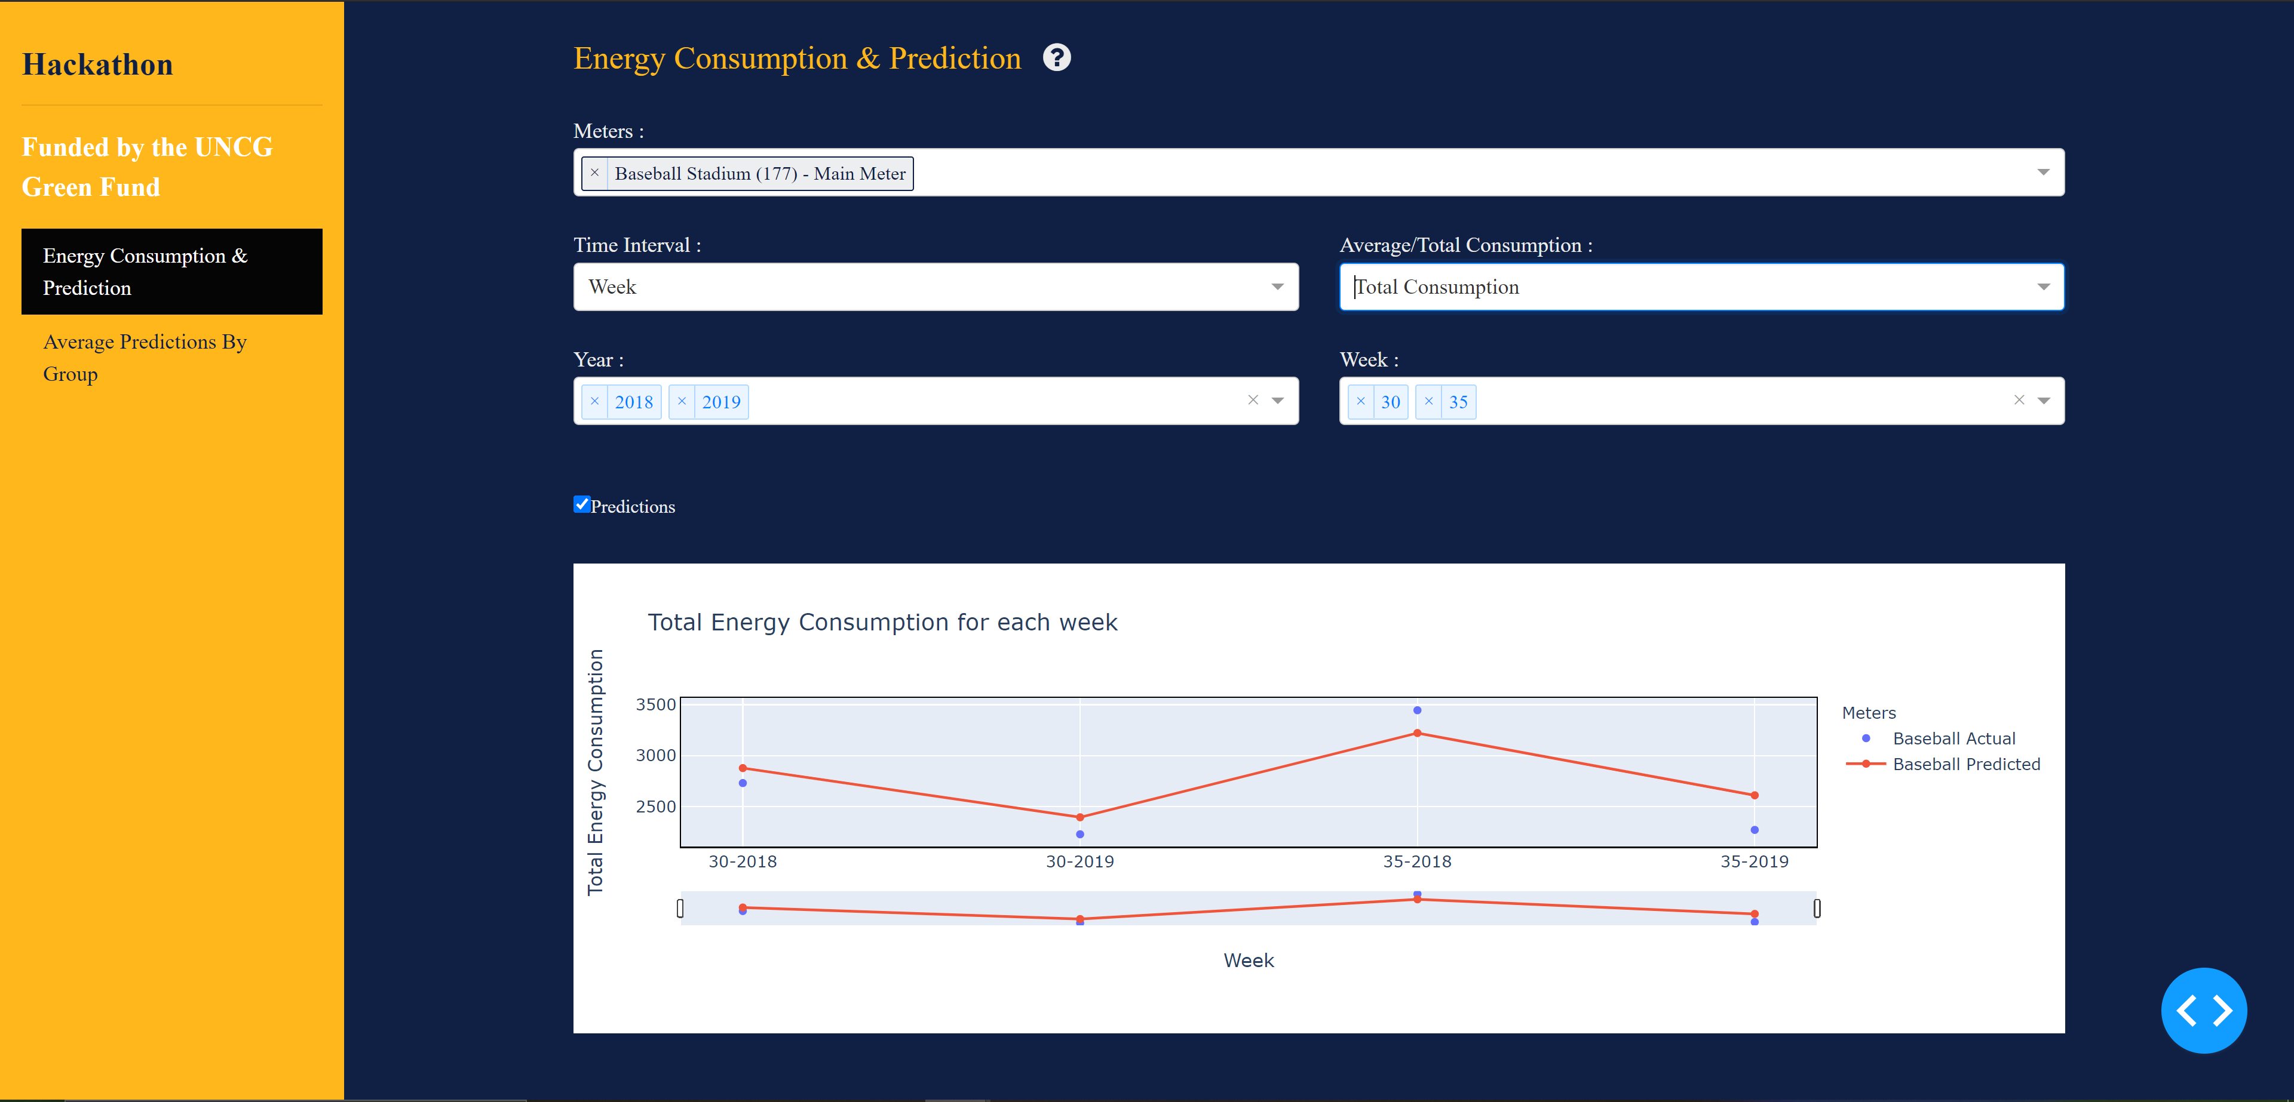

* 1. The below graph shows the average hourly energy consumption by day for Jan 1st 2020 to Jan 2nd 2020 data.

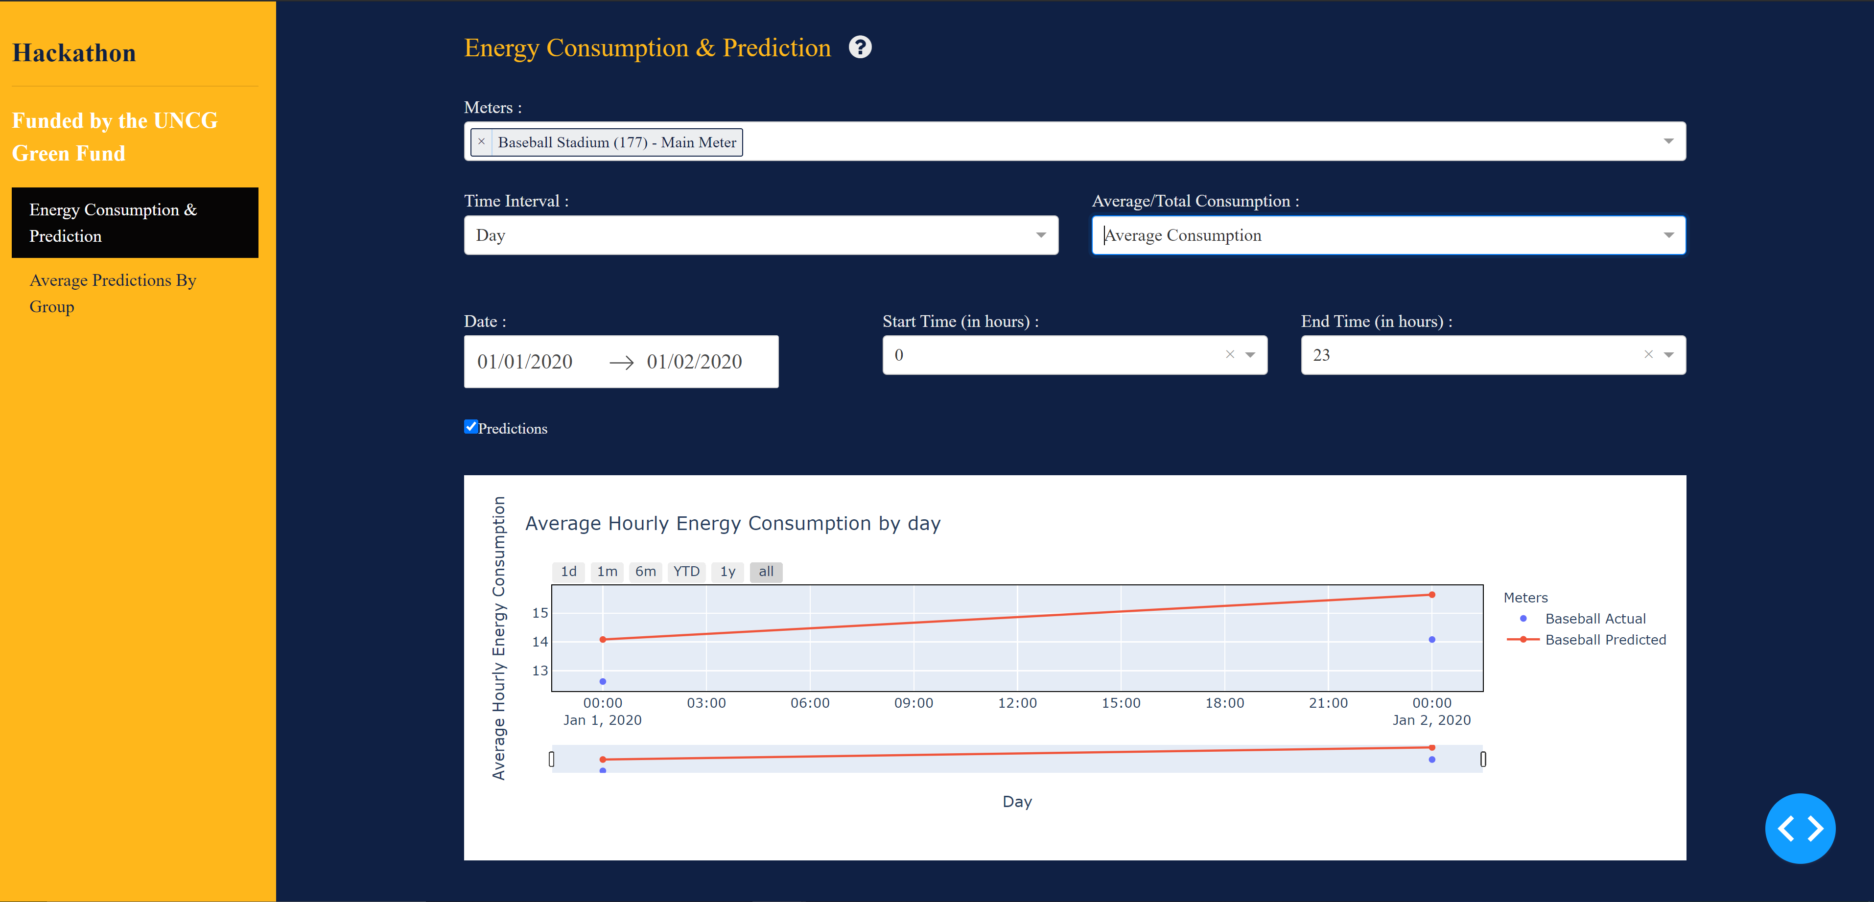

* 1. The below graph shows the Total hourly energy consumption by day for Jan 1st 2020 to Jan 2nd 2020 data.

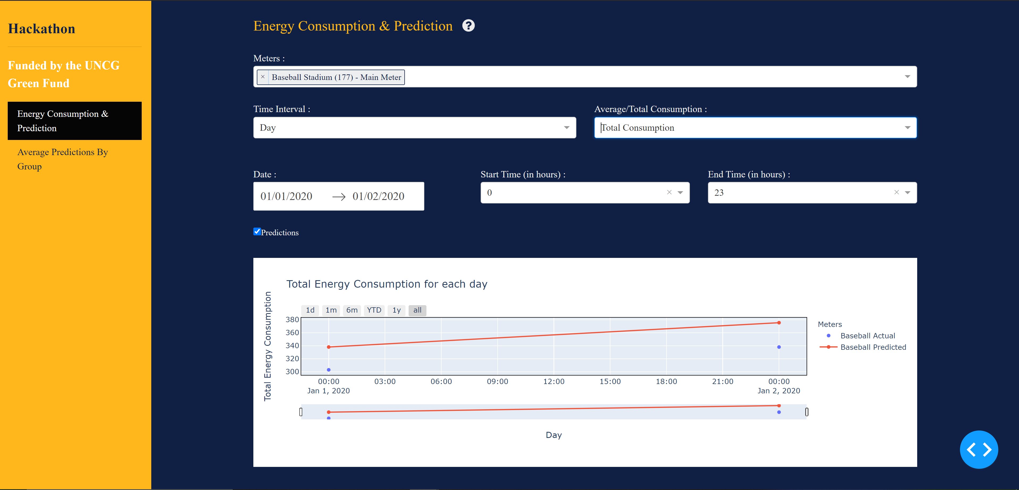

* 1. The below graph shows the Total energy consumption for each hour from Jan 1st 2020 to Jan 2nd 2020

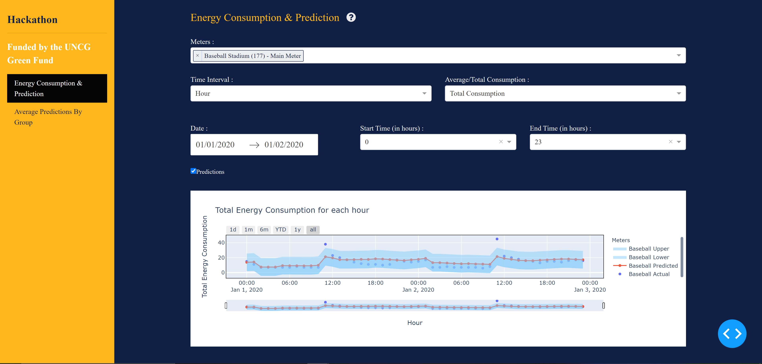

* 1. The below graph shows the Average energy consumption for each hour from Jan 1st 2020 to Jan 2nd 2020

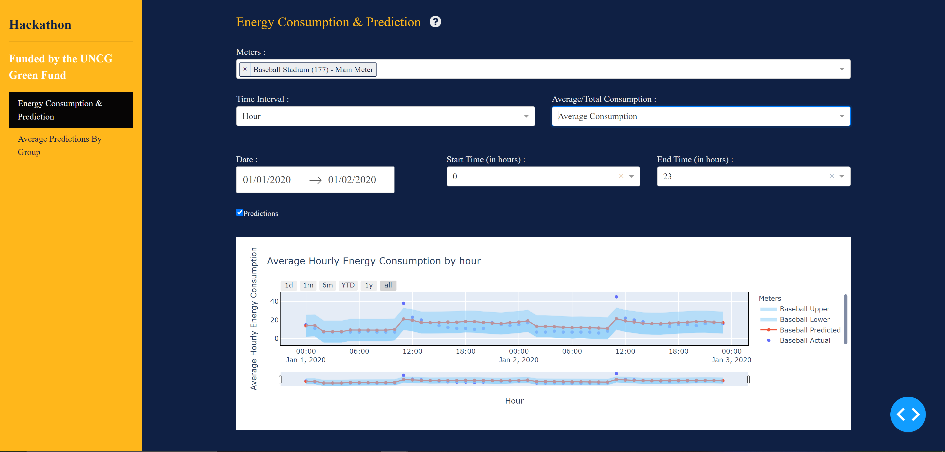

* 1. The below screenshot shows the Average prediction by group of Baseball Stadium(177)- Main Meter’s usage on basis of hour of the day.

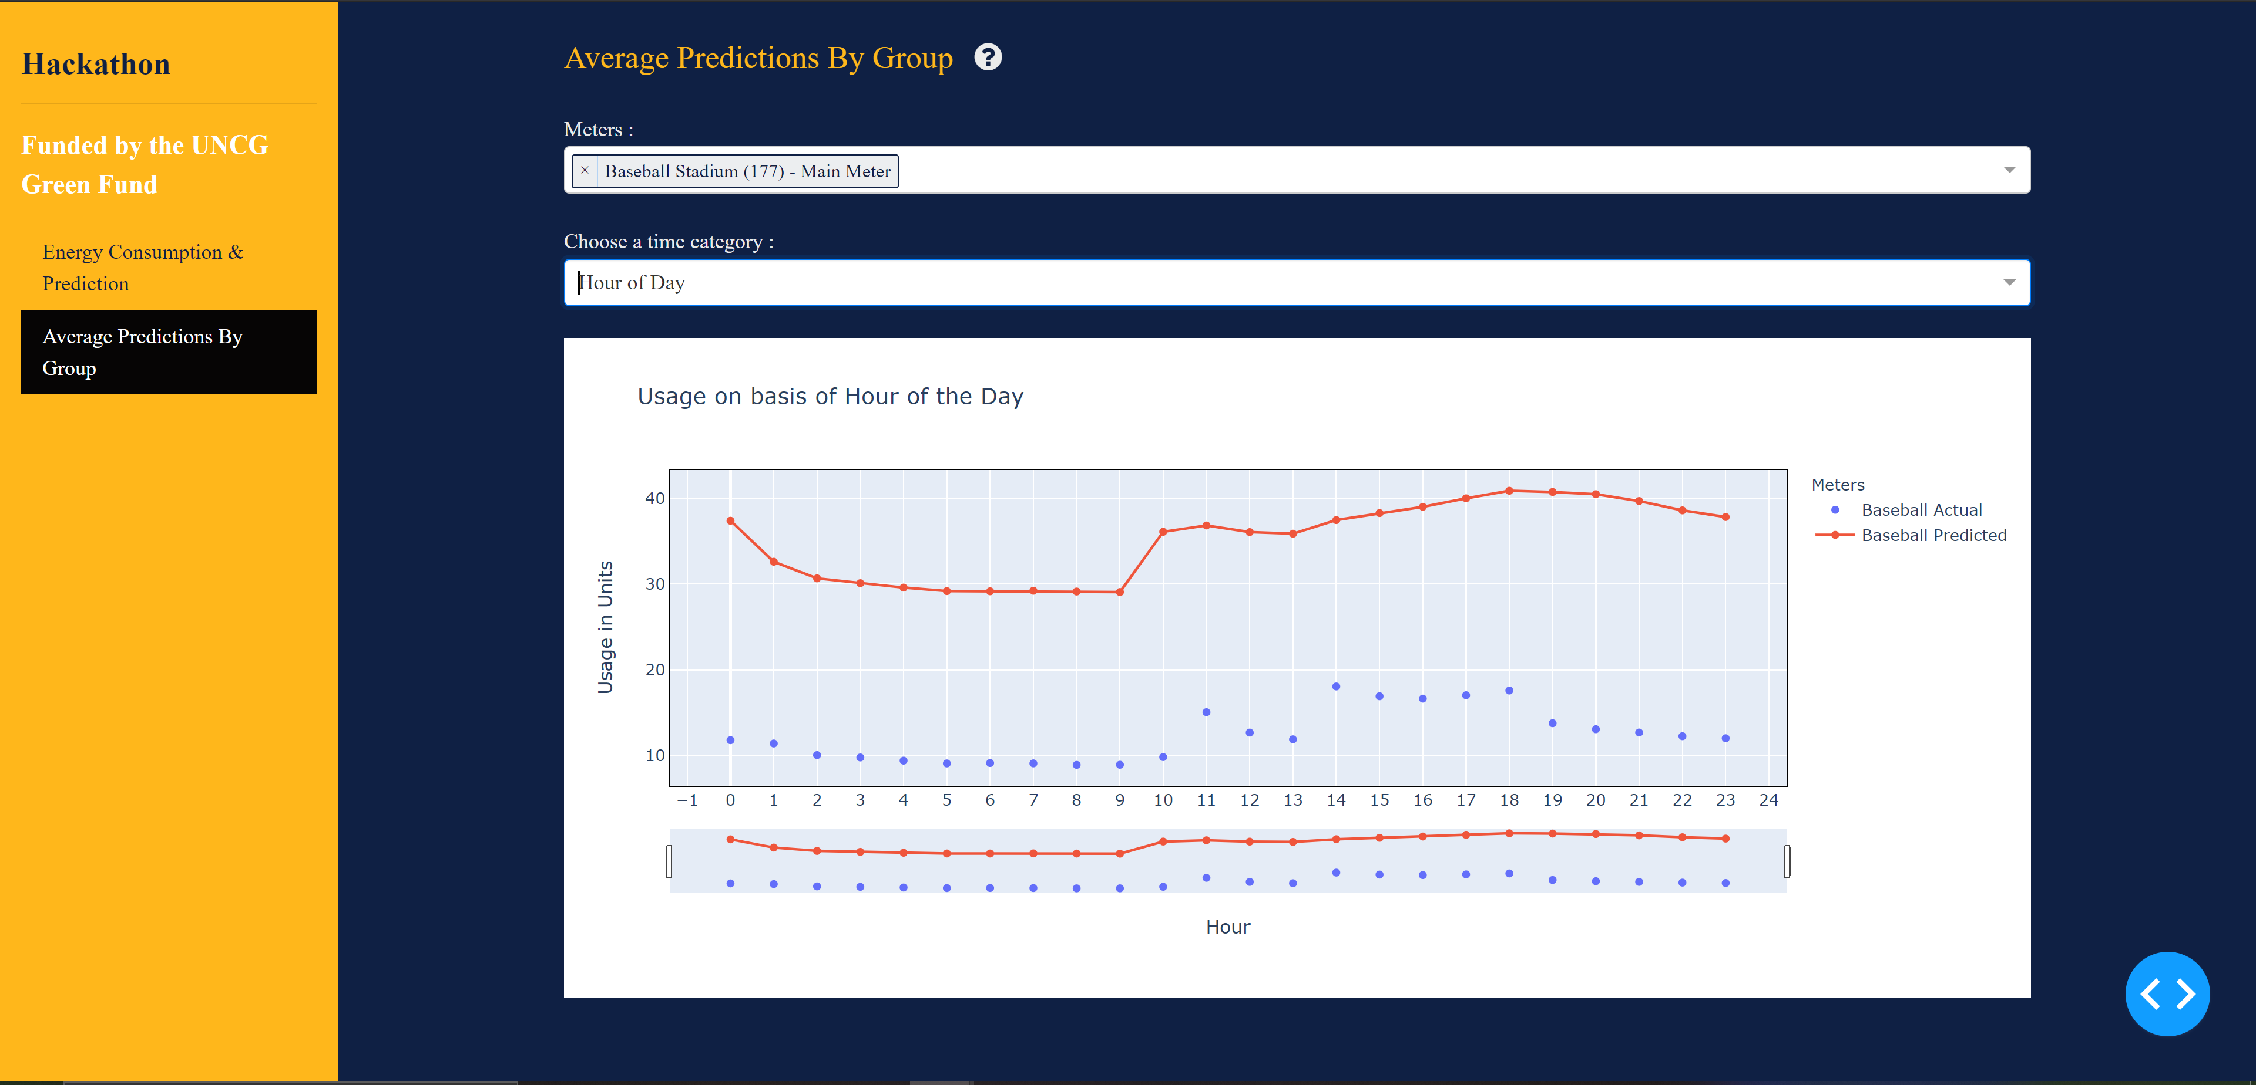

* 1. The below screenshot shows the Average prediction by group of Baseball Stadium(177)- Main Meter’s and Bryan Building(082)-Main Meter usage on basis of hour of the day.

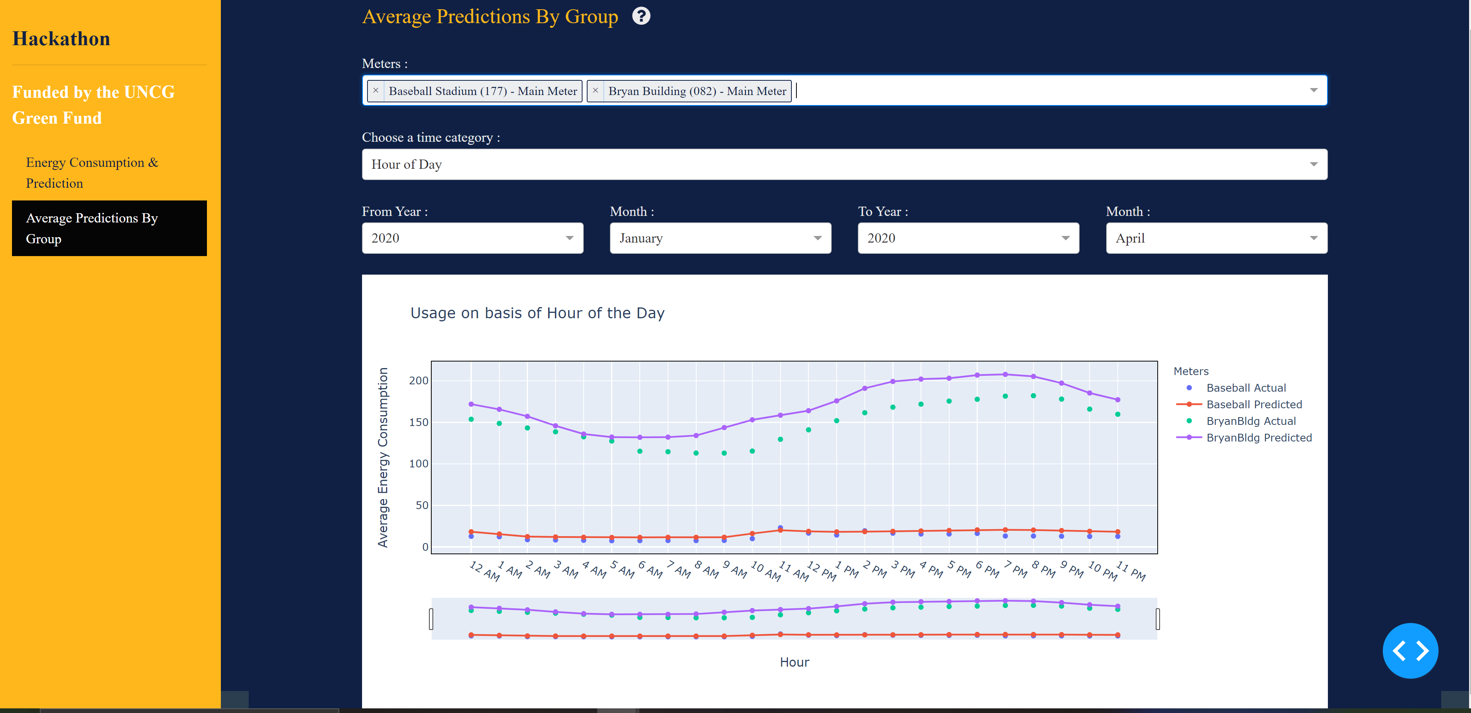

* 1. The below screenshot shows the Average prediction by group of Baseball Stadium(177)- Main Meter’s and Bryan Building(082)-Main Meter usage on basis of day of the week.



4.14 The below screenshot shows the Average prediction by group of Baseball Stadium(177)- Main Meter’s and Bryan Building(082)-Main Meter usage on basis of week of Year.

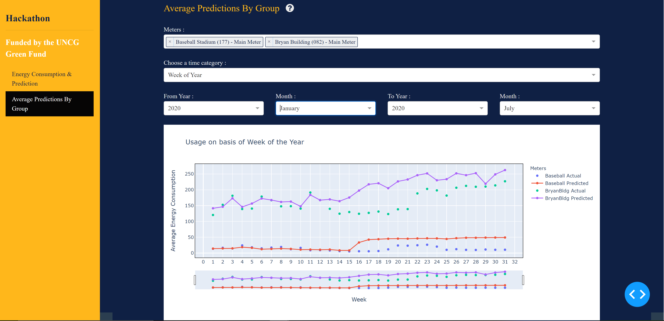

* 1. The below screenshot shows the Average prediction by group of Baseball Stadium(177)- Main Meter’s and Bryan Building(082)-Main Meter usage on basis of Month of the Year.

